Gallery page
Categories  - Awarding Ceremony  - Sports & Activities  - Festivals  - Happy Moments  - Classroom Fun  - School Trips  - Donations  - Community Service  - Free Classes | 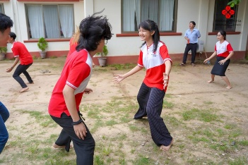 | 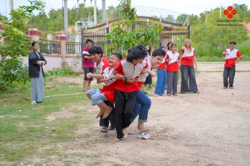 | 